Our Lady of Pity Primary School – Week One

MONDAY | TUESDAY |  | WEDNESDAY |  |  | THURSDAY | FRIDAY
Homemade Pizza  Choose from cheese & tomato or pepperoni. Served with sweetcorn and potato wedges.  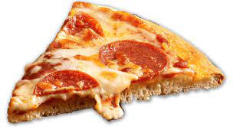 | Pasta Pots  Pasta served with your chosen topping. Choose from tomato or cheese sauce, topped with ham, cheese or pepperoni. Served with sweetcorn.  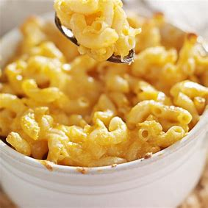 |  | Chicken Wraps  Chicken fillet strips coated in breadcrumbs or Quorn fillets. Served in a wrap with mayonnaise or BBQ sauce. Served with savoury rice and sweetcorn.  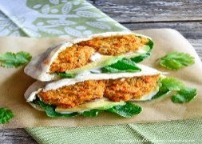 |  |  | Burger Day  Choose from a fresh butcher’s burger or a Quorn Burger. Served in a burger bun with corn on the cob and coleslaw.  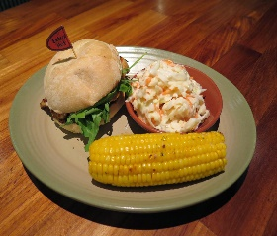  This Photo by Unknown Author is licensed under CC BY-NC-ND | Fish & Chips  Choose from either battered cod fillet, cod fillet fish fingers, or Quorn nuggets. All oven cooked and served with chips, peas, or baked beans.  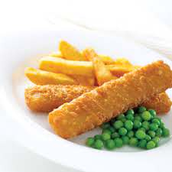
Jacket Potatoes available daily as a hot alternative
Or
Deli Bar – Available Everyday
Design your own sandwich: first choose your bread – wraps, sliced bread or assorted batch,
then choose your filling from a selection of the following: – ham, cheese, tuna, turkey, egg.
Finally, finish with a choice of salad – carrot sticks, cucumber, cherry tomatoes, iceberg lettuce, sweetcorn, coleslaw, beetroot
and peppers.
Dessert
Fresh Fruit, Fruit Pots, Yogurts and Cheese and Crackers are available daily along with the dessert of the day.
Drink
A selection of fresh fruit juice and fresh milkshakes, milk and water will be available daily.

Our Lady of Pity Primary School – Week Two

MONDAY | TUESDAY |  | WEDNESDAY |  |  | THURSDAY | FRIDAY
Paninis  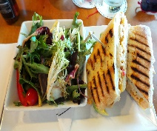  A choice of fillings including, ham, cheese, ham & cheese, tuna melt and pepperoni. Served with corn on the cob, salad, or beans. | Spaghetti Bolognese  Choose from fresh minced beef or vegaterian mince cooked with onions, garlic, tomatoes, and herbs. Served on a bed of pasta with broccoli.  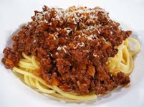 |  | Roast Dinner  Choose from either roast of the day or a Quorn fillet served with a Yorkshire pudding, roast potatoes, carrots and swede and gravy.  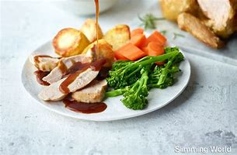 |  |  | Hotdogs  Choose from a  butcher’s quality  sausage or Quorn  sausage. Served in a  finger roll with sweetcorn or beans.  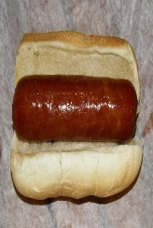  This Photo by Unknown Author is licensed under CC BY-SA-NC | Fish & Chips  Choose from either battered cod fillet, cod fillet fish fingers, or Quorn nuggets. All oven cooked and served with chips, peas, or baked beans.  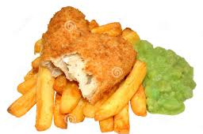
Jacket Potatoes available daily as a hot alternative
Or
Deli Bar – Available Everyday
Design your own sandwich: first choose your bread – wraps, sliced bread or assorted batch,
then choose your filling from a selection of the following: – ham, cheese, tuna, turkey, egg.
Finally, finish with a choice of salad – carrot sticks, cucumber, cherry tomatoes, iceberg lettuce, sweetcorn, coleslaw, beetroot
and peppers.
Dessert
Fresh Fruit, Fruit Pots, Yogurts and Cheese and Crackers are available daily along with the dessert of the day.
Drink
A selection of fresh fruit juice and fresh milkshakes, milk and water will be available daily.

